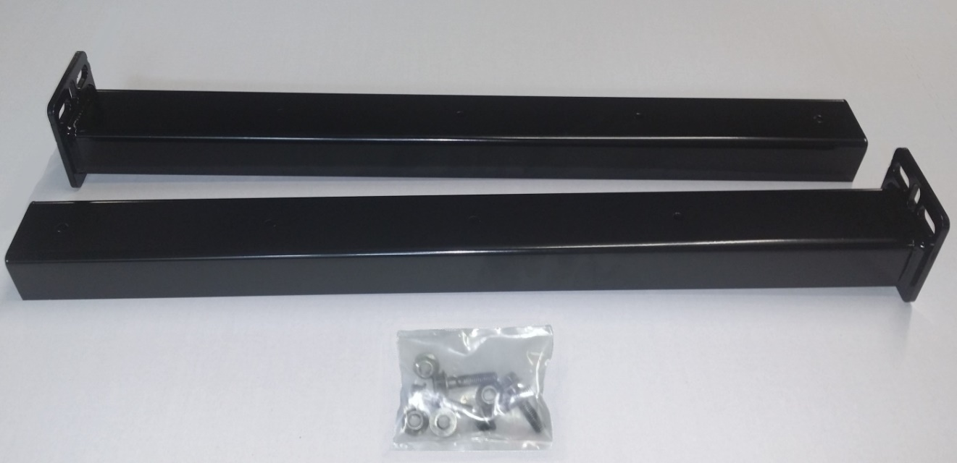

4-BOLTS
4-NUTS

MUD FLAP HANGER KIT #10001460 CONTENTS:
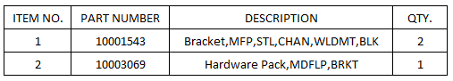

IMPORTANT SAFETY INFORMATION
READ BEFORE INSTALLING OR USING MINIMIZER MUD FLAP HANGERS

SAFETY INSTRUCTIONS FOR INSTALLATION:
- Use Minimizer Mud Flap Hangers only as specified.
- Carefully follow each of the installation instructions on the following pages.
- When using power tools, basic safety precautions should always be taken to reduce the risk of injury.

TOOLS RECOMMENDED FOR INSTALLATION:
- Marker • Drill with 17/32” and 9/16” drill bits
- Impact Driver

IMPORTANT: Prior to installing the hangers on the truck frame, review hole sizes, spacing and check for proper clearances. If you need to drill holes, use a 17/32 up to a 9/16 drill bit. The mud flap hangers have two different bolt pattern options. (See Figure 1)

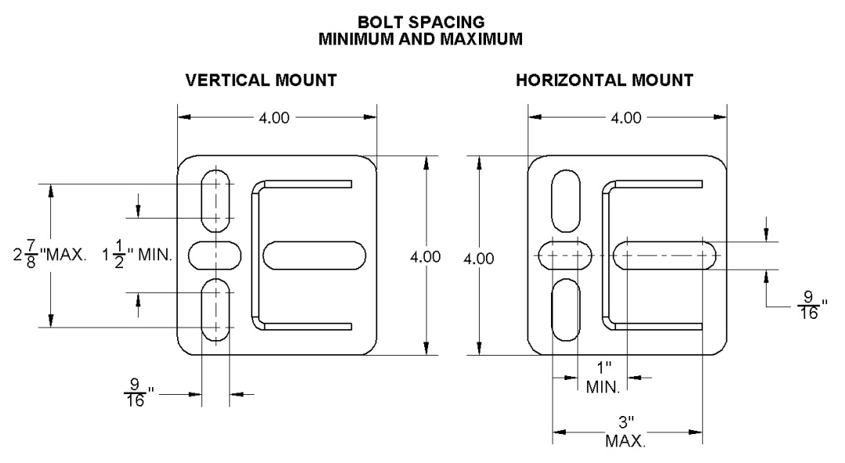

Figure 1

INSTALLATION PROCEDURE:
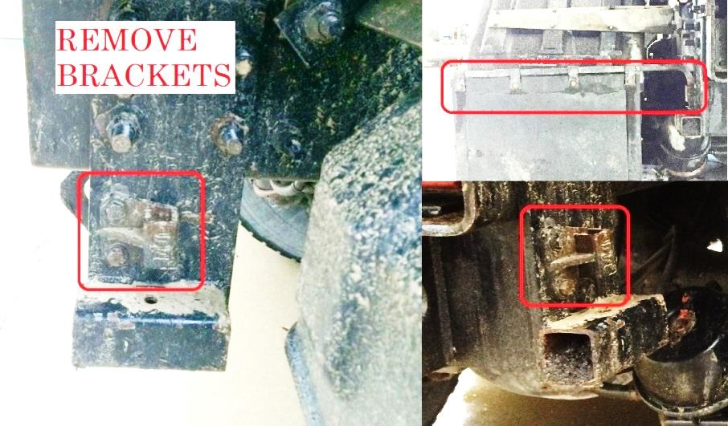
- Remove the existing mud flap hangers from the truck.
(See Figure 2)

- Once removed, inspect the previous bracket location. If raw metal is visible then clean, prime and paint all surfaces where the hangers will be mounted.

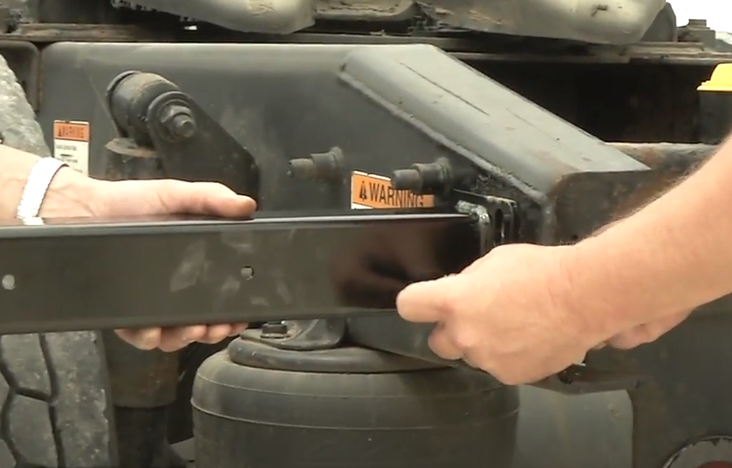
- Use the existing holes in the frame to
Figure 2
install the new mud flap hangers.
(See Figures 3 and 4)

- Due to the different frame configuration of trucks, the existing holes may not be the correct size and/or location. If this is the case, drill new holes using that bracket as a template.

Figure 3
- When hangers are installed, the web of the channel should be facing to the rear
of the truck, similar to Figure 4.

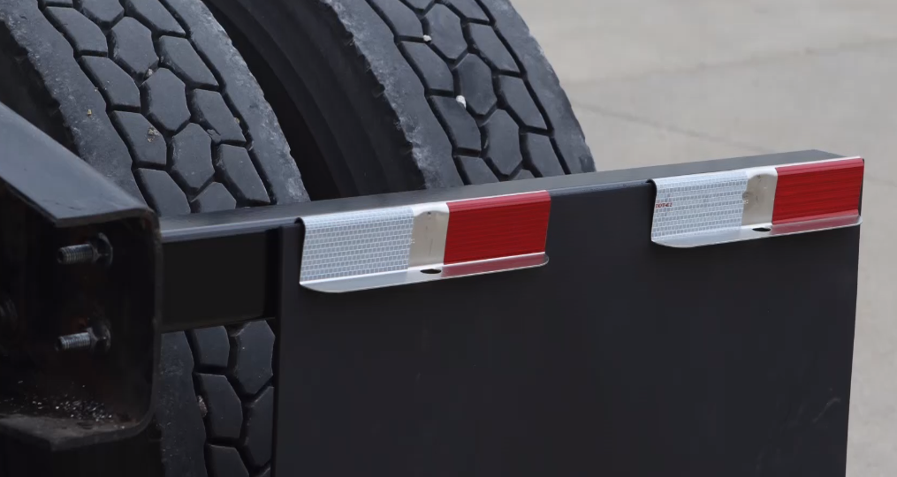

Figure 4

- Once the hangers are attached, proceed with installation of the Fast Flap Bracket system. Part #10001563 (Not included in this kit.)
Note: Follow the Fast Flap installation instructions when installing the Fast Flap brackets.

